
Contact Us

The Primary Care Access Team is based at:

Unit E
Sovereign Business Park
Kingscroft Court
Wigan
WN1 3AP

Tel: 01942 483560
Fax: 01942 483573

We are available for advice by telephone between the hours of 9am & 5pm Monday to Friday
Other Learning Disability Teams can be contacted at:

The ALD Suite
Leigh Locality Office
Grasmere St
Leigh
WN7 1XB

01942 2481719
Mon-Fri 09.00 -17.00

Marsh Green Clinic
Harrow Road
Marsh Green
Wigan
WN5 0QL

01942 483059
Mon-Fri 09.00 -17.00

Database No:ALW025(V3)
Author: Primary Care Access Team
Date Written: February 2013
Review Date: February 2015
Primary Care Access Team

Health & Wellbeing

Care Group
Adult Learning Disability

Information for patients and Carers

NHS Direct - 24 hour advice and health information service

NHS Direct Tel No: 0845 46 47

Local Pharmacy - Your local pharmacies offer a wide range of services including information and general advice on symptom relief medicines as well as a prescription collection and delivery service.

For impartial and confidential advice or information about local health services call our Patient Advice and Liaison Service line on 01942 482778 or 01942 482673

Email: patient.services@bridgewater.nhs.uk




www.bridgewater.nhs.uk

What is a Learning Disability?

Learning disability includes the presence of:

A significantly reduced ability to understand new or complex information, to learn new skills (impaired intelligence) with

A reduced ability to cope independently (impaired social functioning)

Which started before adulthood, with a lasting effect on development.

(Department of Health 2001)

The Primary Care Access Team

We are Learning Disability Nurses providing health and wellbeing support and advice to Adults with Learning Disabilities and their carers.

Referrals

To be referred to us:

- You must agree to the referral

- You must have a learning disability

- You must be 18 years old or over

- You must be registered with a Doctor in the borough

- You must have been offered a learning disability annual health check by your doctor’s practice

Your doctor’s practice will make the referral by completing a referral form and faxing to

(01942) 483573

Or by contacting the Central Duty Team on

(01942) 828777

Our Aim

To help you meet the health needs that have been identified at a Learning Disability annual health check offered by your doctor’s practice.

We Can Help You

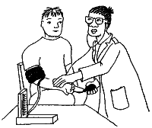 Find out what your
health needs are

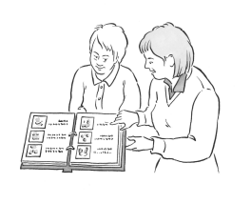Understand your health
needs

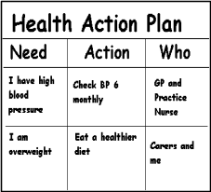
Get your health needs met

